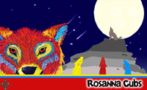

Rosanna Cubs
Pack Holiday / Group Camp!
Eumeralla, Anglesea
Fri 14th-Sun 16th Nov, 2014

Pirates!

Ahoy me hearties! While keeping hidden from those blasted Redcoats (cleverly disguised as Scouts and Venturers camped nearby), our pirate ship is moored at Eumeralla Scout Camp in Anglesea. We need a new crew since the last lot took off with some buried treasure.... and you’re our new Crew! Come aboard as we sail the high seas of Bass Strait and beyond.... to cause mayhem, make ourselves rich and beat those blasted Redcoats in battle!

Location: Eumeralla Scout Camp, 1415 Great Ocean Rd, Anglesea

About it: We will be staying in the Environment Centre, Bunk rooms, which will accommodate our Cubs in boys only/girls only rooms, plus accommodation for Leaders and helpers. Some tents may be used. Also, Kitchen, dining room, toilet and shower facilities. The Scout Camp is in a bush setting with plenty of activities for our Pirates to undertake, including a venture to the beach!
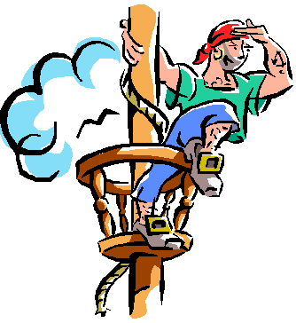
Transport: We will be organising carpooling – parents willing to provide transport, please advise.
Cost: $80 – includes accommodation, food, activities and equipment. For those wanting
to do surfing (run by “Go Ride a Wave”), extra cost is $40 (total $120).
Leaders: Our Leaders will be attending, plus some volunteer parents are needed
for Cooking etc. (Need Working with Children and, for our Cook,
experience in catering/cooking for large groups). Please advise ASAP.
Depart: Meet at the Scout Hall at 6pm, Fri 14th Nov. - 6:30pm departure.
Return: 1:45 pm Sunday, 16th Nov – depart from Anglesea
3:15-3:30 pm arrive back at Scout Hall.
Take: Kit list is available on the paperwork/downloads page of our website. NOTE: All
our Pirates can bring along an appropriate costume if they like. ALSO, very old clothes for the Cold War (flour fight) AND large plastic bags for safe return of the clothes home! Lastly, we need togs, towels etc., for the beach!
NO: Phones, MP3 players, iPods, electronic games, radios or similar may not be taken.

Please email confirmation of attendance (or non-attendance to akela@rosannacubs.org ASAP, and return the form below and full $80 or $120 (if surfing) payment on Tues 11th Nov.

The Leaders
Rosanna Cub Scouts http://www.rosannacubs.org

Permission Form – Rosanna Cubs Pack Holiday /Group Camp

I give my permission and attach $80 payment for ____________________________________ to attend the 2014 Pack Holiday at Eumeralla, 14-16 Nov. I DO/DO NOT give permission for my child to take part in the Surfing Lessons program and, if taking part I attach an extra $40 (Total $120)
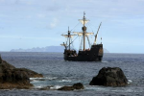
Special Dietary Requirements (for catering purposes – please tell us ASAP)

___ _____

IF doing surfing... please provide details of any medical/disability/inability to swim issues that may affect surfing (or write “none”):

_______________________________________________________________
I understand that transport to and from the camp will be by carpooling

Signature of parent or guardian ______________________________ Print Name __________________

